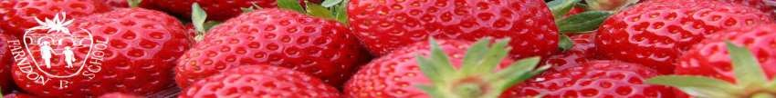

**British Values within the Early Years Foundation Stage**

**Democracy**

This forms part of our work in Personal, Social and Emotional Development.

Managers and staff encourage children to see their role in the “bigger picture”. They encourage children to know their views count, value each other’s views and values and talk about their feelings. Children have the opportunity to share views on what theme they would like to study of the inspiration for their role play.

Staff support decisions that children make and provide opportunities for turn taking and sharing. Children are actively encouraged to develop an enquiring mind where questions are encouraged. Pupils also took part in the school’s own election and campaign leaders spoke with the children about local issues.

**Rule of Law**

This is part of managing feelings and behaviour. Staff ensure that children understand their own and other’s behaviour and its consequences; they learn to distinguish between right and wrong.

Staff collaborate with children to create the rules and codes of behaviour. The behaviour policy and the school values are clearly displayed around school and in the EYFS unit.

**Individual Liberty**

As part of our wok on self-confidence and self-awareness and people and communities. Children develop a positive sense of themselves. Staff provide opportunities for children to develop their self-knowledge, self-esteem and increase their confidence in their own abilities. For example, through allowing children to take risks on adventurous play, mixing colours and talking about experiences.

Staff plan to deliver a range of experiences that allow children to explore the language of feelings and responsibility, reflect on their differences and understand we are free to have different opinions.

**Mutual Respect and Tolerance**

This is part of our PSED and Understanding the World.

Leaders create an ethos of inclusivity and tolerance where views, faiths, cultures and races are valued and children engage with the local community. For example, they experienced elements of Islamic religious festivals, acting out actually flying to another country.

Children acquire tolerance and appreciation of and respect for their own cultures through the global learning programme. They know similarities and differences between themselves and others and among families, faiths, cultures and traditions. In our global learning sessions, we discuss practice, celebrations and experiences.

Staff promote diversity through display and bi-lingual signage. We promote diverse attitudes and challenge stereotypes when sharing stories that reflect and value diversity of children’s experiences.