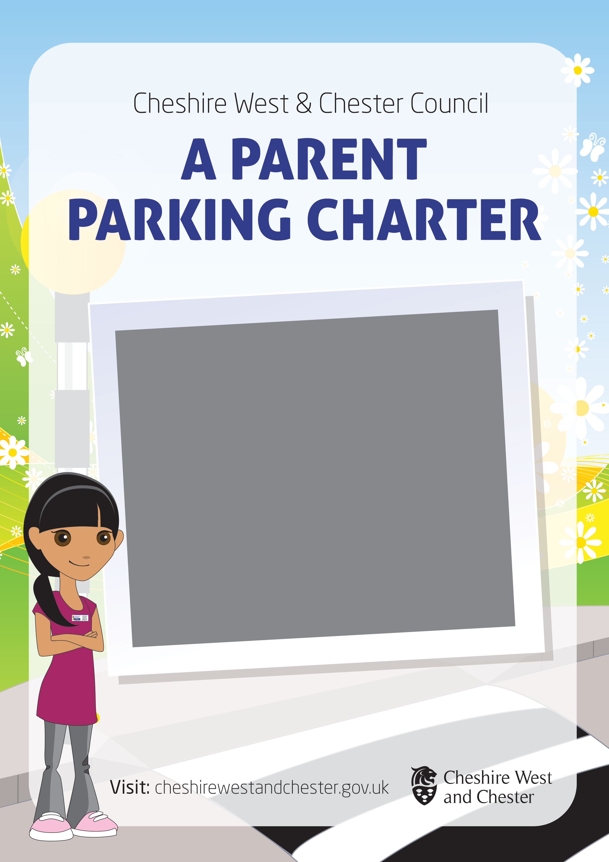



Creating a safer parking charter
The safety of children and adults attending or travelling to local schools is a major concern. We appreciate that the area around schools is likely to be very busy during peak travelling times but we need to reduce occurrences of dangerous parking and congestion as much as possible.
This information is provided to help you develop parents' safer parking charter that you can amend and make more specific to the environment and problems associated with your school.
Guidance on how to introduce a safer parking charter
Firstly, for any safer parking scheme to be successful it must have the support and compliance of parents which means you should inform and involve them as early on in the process as possible. You should also make sure you offer parents the chance to give feedback on any proposals. It is a good idea to consider introducing proposals through your Pupil Council because this will help raise awareness amongst pupils of the dangers on the road. This approach is also more likely to gain greater support from parents.
Getting started
A good place to start is to send information home to parents which highlight why dangerous parking is such a concern and why the school "zig-zag" markings are in place. We recommend that in all communications you focus on education and encouragement rather than on any threat of prosecution.
Information can be distributed and feedback sought through the school website and newsletters. This will help to keep parents and pupils up to date with progress and keep them involved. Engaging staff and pupils at other school events such as sports days, parents' evenings and open days is also a good way of generating interest. A new leaflet ‘A polite request’ is available to school for distribution.
Some schools may be in a position to work with local businesses to discuss additional parking provision further away from school. This can provide a safer place for parents to park and some promotion for those businesses involved.
Sample 'Parents' safer parking Charter'
A sample charter is available which can be adapted to the individual needs of each school.
For help with this please contact roadsafety@cheshirewestandchester.gov.uk

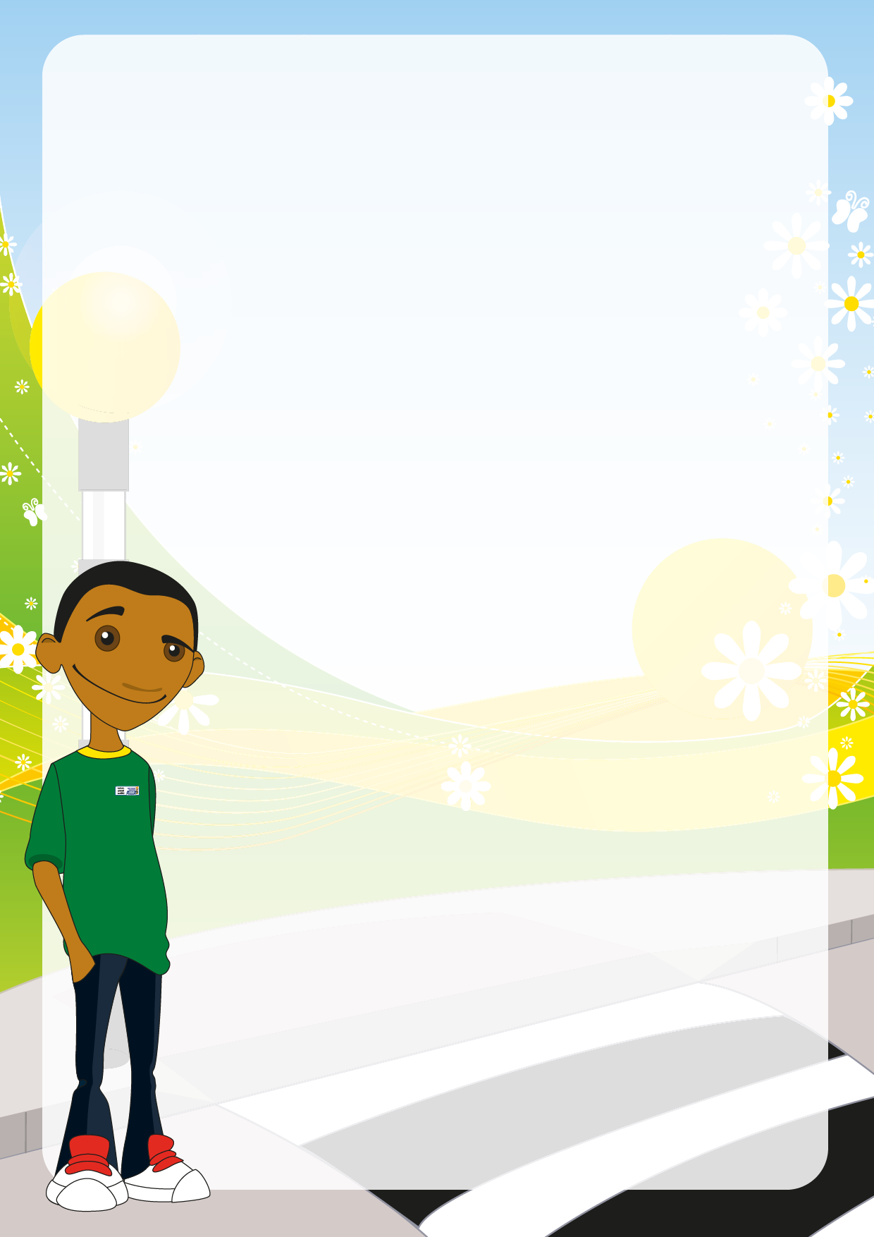
OTHER WAYS TO SPREAD THE WORD

Run a poster competition
Run a poster or leaflet competition regarding safer parking and the "zig-zag" markings across the year groups. The designs could be displayed in school with the winning design being printed into a leaflet and sent home to parents or put on your website.
Sign up to the Safer Schools Parking Banner scheme
The Safer Schools Parking Banner scheme highlights the dangers of parking on the zigzag "School Keep Clear" markings, parking too close to schools and the congestion that this can create. The scheme is organised by our Road Safety Team and locality officers and was launched in September 2014 at Lache Primary School, Chester.
When you sign up to the scheme you may be given two banners that you can display outside your school, subject to funding. Each banner has a different message to raise awareness of parking safely. You can monitor the effect that each banner is having. Information could also be sent to parents and carers highlighting the scheme and other safety initiatives carried out at your school.
We hope to reduce congestion and conflict outside schools by changing the behaviour of drivers. We ask that parents and carers support the scheme by not parking outside schools. Enforcement
can be used as an option to highlight the issues created by dangerous parking, but
ultimately the success of the scheme will depend on the compliance of drivers.

To sign your school up to the scheme please phone our Road Safety Team on
0300 1237036 or email roadsafety@cheshirewestandchester.gov.uk
Linking safer parking to the curriculum
There are numerous ways that you can link road safety and the issue of dangerous
parking to the curriculum.
Science
Children can look at the long term benefits of regular exercise on the body, focusing on
the heart and obesity. They could also look at the affects of excess pollution and carbon
dioxide on the atmosphere.
Mathematics
Children could undertake a comparison of traffic surveys prior to and after any
introduction of a safer parking initiative. They could analyse their results and use
different methods of portraying their findings.
English
Children can undertake various creative writing exercises or develop newspaper articles
to put across persuasive arguments and information regarding parking outside their
school.

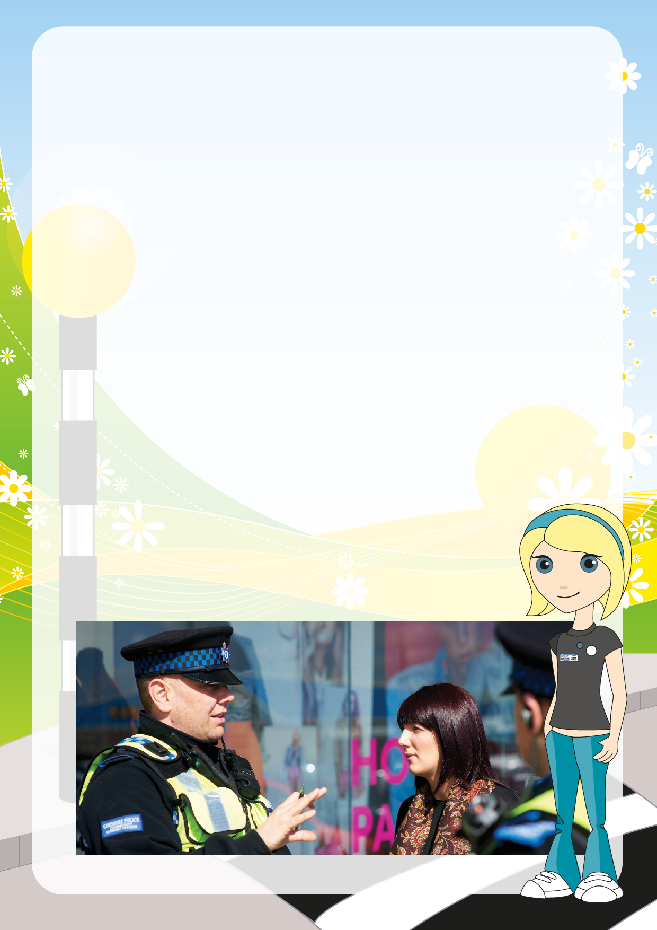
WHO ELSE CAN HELP?

Cheshire West Road Safety Team
Our Road Safety Team offers a programme of road safety education that is delivered at primary schools. This involves a range of in-class and practical lessons designed to help increase road user confidence, knowledge and skill. They can also offer resources to pre-school groups.
To enquire about road safety in your school please phone our Road Safety Team on 0300 1237036 or email: roadsafety@cheshirewestandchester.gov.uk
Parking Services
Most primary and secondary schools within the borough of Cheshire West are already on the attention list for enforcement by wardens. To discuss safer parking or parking enforcement outside your school please contact customer services 0300 1237036
Police Community Support Officers
Contact your local PCSO by telephoning 101 to see how they might be able to support your school and pupils.

How parents can help reduce congestion
Keep the immediate environment outside school as traffic free as possible - this will provide a safer environment for those travelling to and from school and a better environment for the School Crossing Patrol.
Park further away from school and walk the last part of your journey - use this as an opportunity to practice road safety and safer pedestrian skills with your child.
Car share with friends to reduce the number of vehicles travelling to school - you could take it in turns to help reduce the demands of the school run.
If at all possible walk to school

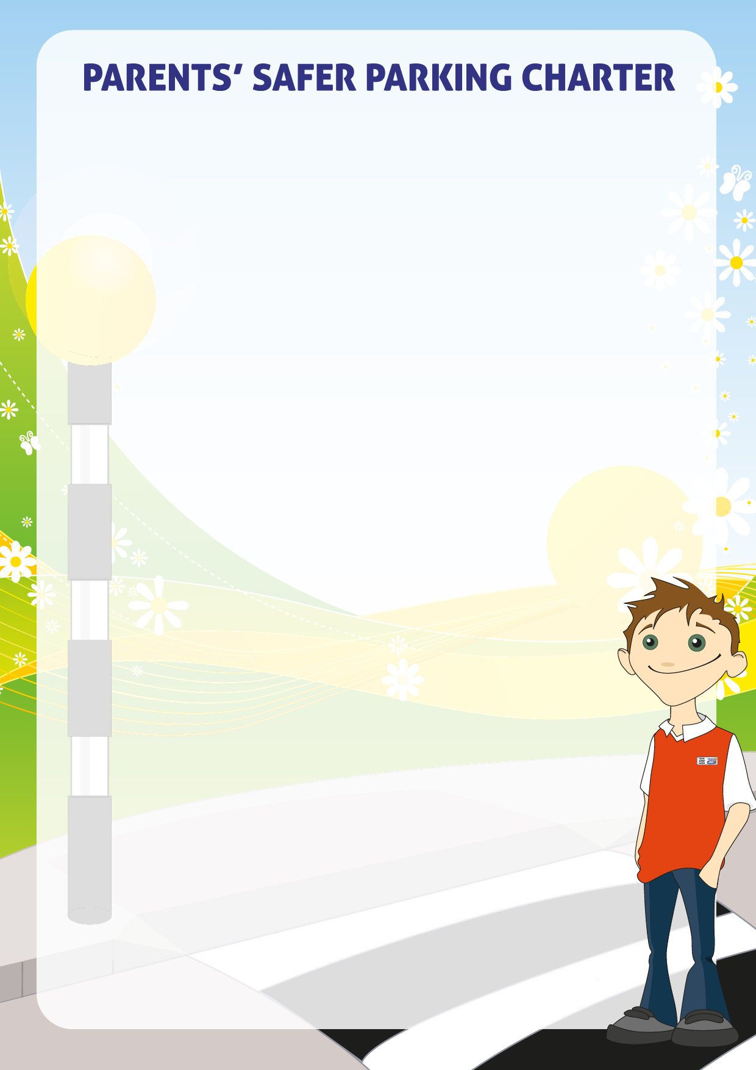
The Junior Safety Officers, Parents and school have constructed a Safe Parking Charter. They want everyone who drives to Farndon Primary School to sign up to the following Parking Charter to help keep all of us safe. Please remember road safety is everyone’s responsibility.
I hereby agree to abide by the guidelines outlined within the Safer Parking Charter, which has been established by the Farndon School Pupils, Teachers and Cheshire West and Chester Council’s Road Safety Team. This charter has been developed to improve the safety of children and adults attending Farndon Primary School and improve the quality of life for those within the school environment. By signing up to this charter you agree to:
Drive safely, within the school area, adhering to the speed limits and driving in accordance with the Highway Code.
Leave in plenty of time for the school run and if possible park away from school and walk the rest of the way with your children to school.
Please don’t park or drop off on the “School - Keep – Clear” and “zig-zag” lines, leave earlier so you can park somewhere else safe so that there is no danger for children walking to school, then everybody is safe to and from school.
Not to park on any double yellow lines.
Please don’t block driveways because if someone needs to get out for an emergency or doctor’s appointment and they could be ill.
Don’t drop off or pick up your children in the school car park because it can stop school staff getting in and then they park on the road making more traffic.
Don’t let your children get out in the middle of the road because they are at risk and could get hit by a car so try and park where your children can get out on the pavement side.
Make sure you indicate before you move or let children out and be aware of children around your vehicle.
Avoid double parking, this stops traffic moving and means the road is even busier.
Don’t leave your car running as that sends fumes into the air and creates pollution. Please think before you do as the fumes get stuck in children’s lungs and that could cause sickness.
If you have time-park in the Farndon car park and then walk your child to school to free up space, you might even enjoy the walk!
Respect local residents and businesses by not parking in a way that blocks access or egress to their homes or premises.
If possible car share.
To forward any concerns regarding dangerous parking and road safety in the school environment to the Head teacher or a Governor, who can then take appropriate action.

I/we have read and understood the Farndon School Safer Parking Charter and agree to abide by all the guidelines to help ensure the safety of all children.
Child’s Name………………………………………………………. Class………………………………………….…………

Signed: ……………………………………………………………… Date…………………………………………….…………

If at all possible Walk to School

