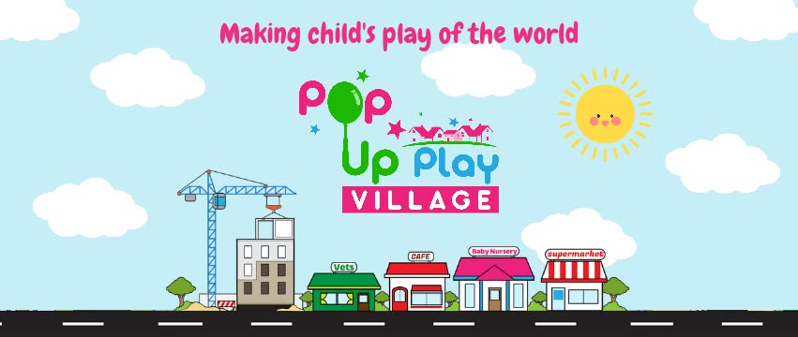Dear Parents,

Just a note to clarify our Pop-Up Play Village sessions. Although on the advert it states that ages 0-8 are catered for, because this is an in-schooltime session, it is aimed at 0-3 year olds. Kelly (the lady that runs the company) does host holiday clubs and parties so if you are interested in attending one of these sessions with an older child, please visit her Facebook page for details: [www.facebook.com/PopUpPlayVillageChester/](http://www.facebook.com/PopUpPlayVillageChester/)

It is hoped that we can host these Friday morning sessions for the foreseeable future and become a valuable Baby and Toddler group for the whole village.

In addition to the above community sessions, our PTA have very kindly agreed to fund some in-school sessions for our Reception class with Pop-Up Play Village so watch out for photos from those after the Easter Break.

If you have any further questions, please come and have a chat to me and I will try my best to help.

Kind regards

Mrs Wakefield