**The Autism Service**

**Transition to High School Online Event**

**(Via Microsoft Teams)**

**Date: 11.2.25 Time: 10am– 2pm**

**We are inviting all parents, carers and professionals supporting children in years 4, 5 and 6 to attend.**

**What’s happening?**

There will be opportunities to attend workshops via Microsoft Teams and these will be delivered by The Autism Service Teachers. Workshops will include:

* Supporting organisation and independence
* Developing strategies to address emotional well-being
* Supporting the communication needs of the young person

There will also be information provided by High school and Primary school SENCOs focusing on effective joint parent/school working. There will be regular breaks throughout the day.

Following the event you will receive a copy of The Autism Service Transition to High School Pack, and this will be a useful tool to use with the child you are supporting.

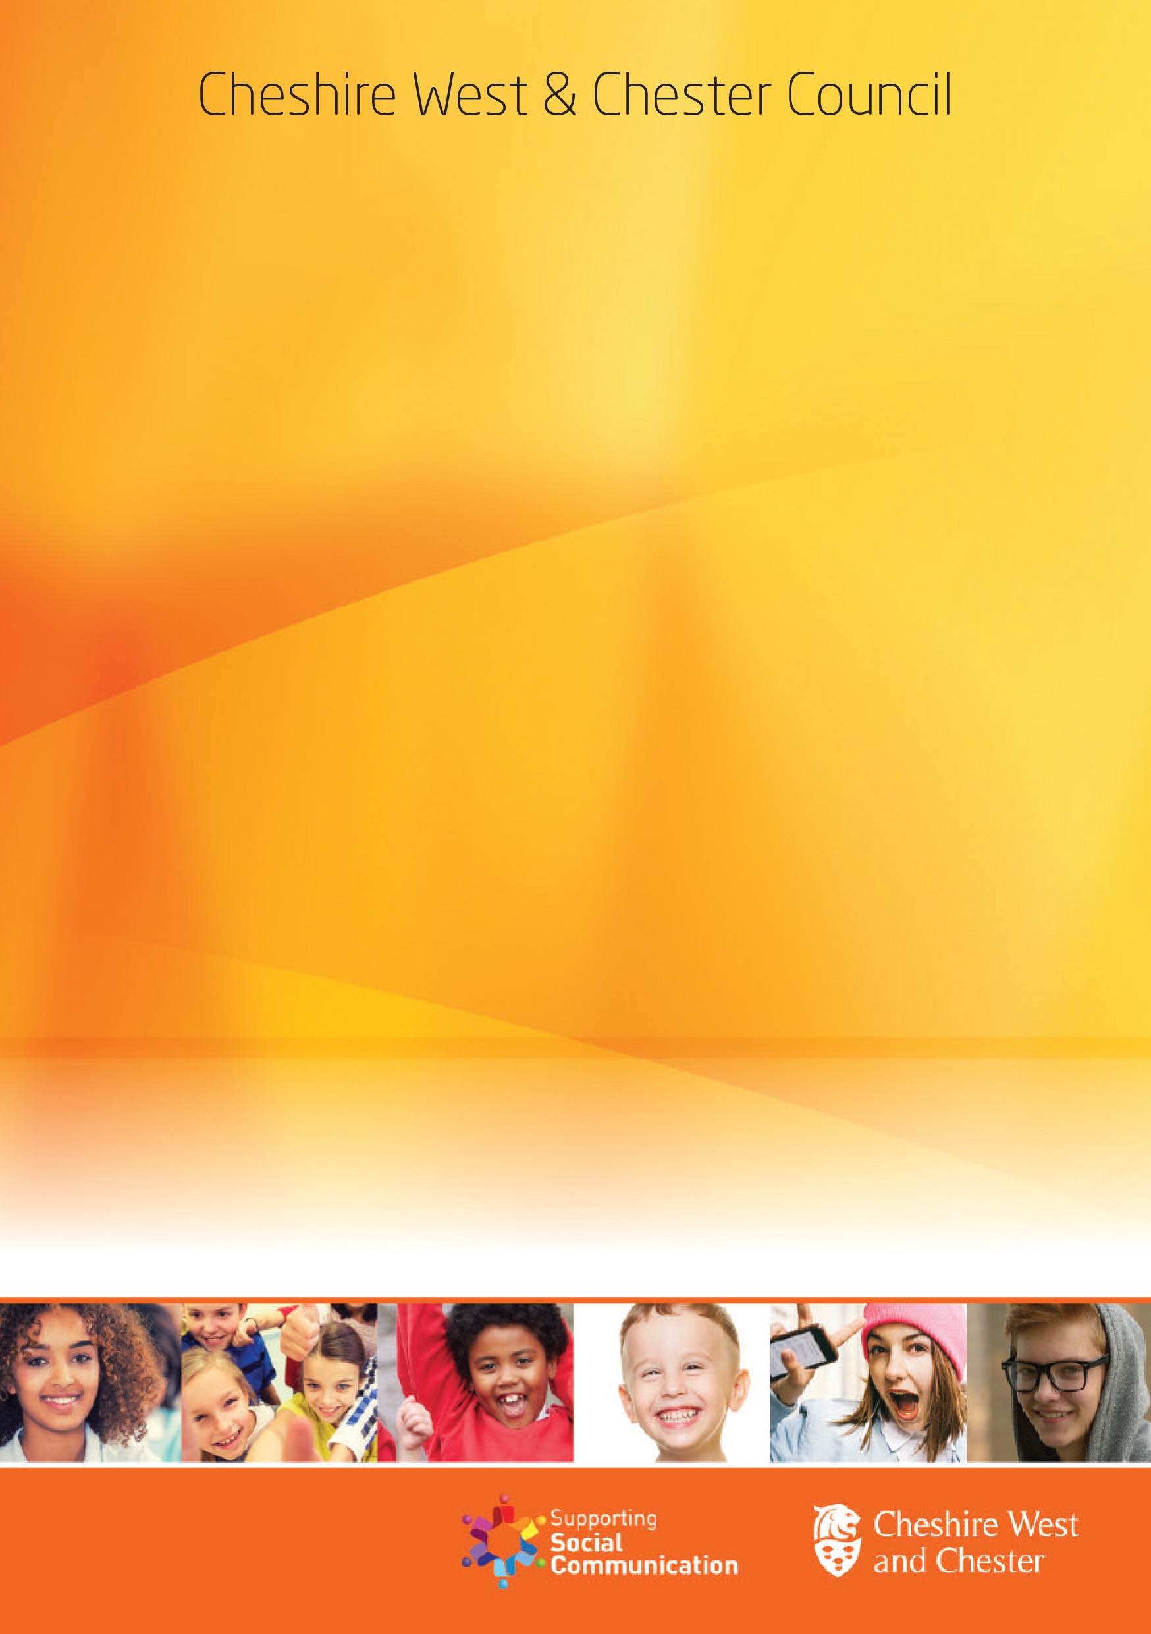

[**https://www.smartsurvey.co.uk/s/tranhigh1102/**](https://www.smartsurvey.co.uk/s/tranhigh1102/)

**To apply please click on the link below OR scan the QR code to complete the short application form.**

**Please note that the closing date for applications will be Tuesday 4th February You will receive your link and any visual pre course information by Friday 7th February 2025.**