 Unlocking the potential…
Over view of Sports Allocated Sports Grant expenditure 2024 / 25 to enhance the quality and breadth of PE and sports provision
PE is a part of every child’s entitlement to a good education. It provides pupils with the generic skills, knowledge and understanding they need to become physically literate, and at the same time gives most of them their first regular experiences of sport. When taught well, PE enthuses and inspires pupils to participate fully and develop a life-long love of physical activity, sport and exercise.
Sport Premium Funding
This funding is ring fenced and can only be spent on improving provision of PE and sport in school. The DfE guidance states that possible uses for the funding may be:

- hiring specialist teachers / coaches to work with Primary teachers when teaching PE.
- paying for professional development opportunities for teachers in PE and sport.
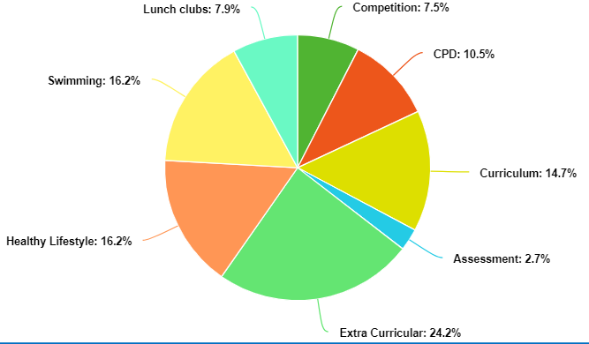
- running sporting competitions, or increasing pupils’ participation in the School Games.
- buying quality assured professional development modules or materials for PE and sport.
- providing places for pupils on after school sports clubs and holiday clubs.
- hiring specialist teachers / coaches to deliver modules on healthy lifestyles and swimming.

Money received in the School Budget 2024 / 25
Total number of pupils on roll | 280
Total amount of Sports Allocated Sports Grant received | £18,535

Provision 2024 / 25
Sports Coaching Group to provide 2.5 whole days. 3 clubs after school, 2 morning clubs and 3 lunch time clubs.. Also, we will continue with the Heber High School.
The money comes in 2 stages: 7/12 in November and 5/12 in May.
Heber High Link  £1020 | Participation in a yearly programme of sporting competitions across the whole year for all different ages, including the following: cross country, tag rugby, hockey, football, handball, netball, rounders and cricket.
Heber High Link  £1020 | Playground leader programme. This aims to develop young leaders within your school who will be able to deliver high-quality physical activity sessions for younger children across break and lunch times.
Heber High Link  £1020 | CPD for 2 members of staff (primarily the teaching of gymnastics) where they observe best practise teaching2 x ½ days.
Chester Sports Competition Link  £125 | Participation in the Upper Junior and Lower Junior football leagues and netball league.  Participation in athletics events.
Hoops for Health Workshop  £250 | Healthy living workshop and after school club.  Work with Yr 5 and 6 pupils on healthy living. Basketball club after school x 3 sessions and participation in a tournament on the Chester Phoenix court.
Quality Assured training and CPD for staff in Dance.  £1950 | Dance Curriculum: Sports coaching group member of staff to come in Summer and deliver 6 week dance units for every class from Year 1 to Year 6. Staff to watch for CPD and assessment purposes.
Mindfulness groups  £3000 | School’s mental health champion to organise and lead mindfulness workshops for children for their mental wellbeing. This will include therapy dog; SHINE clubs; Nuture groups; Mindfulness programme taught in classes.
Pupil Fitness and swimming instruction  £3000 | Pools for Schools. A 10m by 5m swimming pool to be installed on the school grounds in May. This will be covered and come with a lifeguard and swimming tutor. It will be for all Year 3 and 4 pupils and non-swimming Year 5 and 6 pupils. Total cost is £3500. The PTA will pay some money towards and we will also charge parents for the use of the pool. It will also be used for swimming clubs after school for the Infants. Additional money is to cover the costs of water and electric.
Sports Coaching Group £17,965
Cost of Sports Coaching Group Breakdown  £4490 | Key Stage 1 club every half term  Lower Key Stage 2 club every half term  Upper Key Stage 2 club every half term  Morning Club Upper Junior  Morning Club Lower Junior
£1470 | 3 x Lunch time clubs. There is an overview for the whole year with trials for each of the tournaments and time to prepare with a focus on tactics and shape. This frees up the curriculum for the focus on quality teaching and the build-up of skills.
Curriculum Provision  £7,905 | New PE sports curriculum that is online and accessible to all staff, including sports coaches. This gives key skills, key knowledge and fundamental skill that are to be taught in each unit. Planning is available for Pre-School – Year 6. This ensures a coherent and cohesive curriculum is in place. For Early Years, there are specific units linked to EYFS curriculum such as Locomotion; Fine Motor Skills; Target Skills and Stability.
Curriculum Assessment  £5000 | Purchasing access to PE Passport. This gives staff the function of online assessment for each pupil in all PE units taught. For each unit taught, there are I can… statements to assess against. Also, the Sports Coach will begin to add assessment evidence in the form of photographs. Finally, the Sports will include all sports clubs and the pupils accessing them. PE lead to add any sports club offered additionally to those currently planned by Sportscape.
Total Expenditure | £27,035
Total Income  Approx with parental contribution | £18,259 Sports Premium  £9000 Clubs / Swimming income  Total Income: £27,259 | Total Under / Over Spend | - Potential income of £224

