
Cheshire West and Chester Council
Farndon Primary School
Churton Road
Farndon
Chester
CH3 6QP

Telephone: 01244 621124

Headteacher: Mr A. Walker Email: head@farndon.cheshire.sch.uk
________ _________________________________________________________________________________________________

Dear Parents / Carers,

Since coming back in January, we have begun to utilise the additional services on the School Spider app, which will enable us to send messages, set up surveys and questionnaires and provide a digital platform for when booking in parent’s evening appointments.

If you haven’t downloaded it already, the process is relatively straight forward – and the steps on how to do it are below.

- On the App where you usually go to download

new applications, simple type in the search bar
“School Spider app”. The image for the app is
displayed here on the right.

- Your first step to set up is to create an account.

- You will then be asked to type in your e-mail. Please use the
one which you gave to the school office.

- Type in your email and then select Farndon Primary School.

- Check your email and it will send you a link to set a new password.
It will also display your username which you will need to log in.

- Reset your new password and then log in with your username and
new password.

- This should complete the process and your child/children should
be linked.

If you have any trouble with the setting up of this
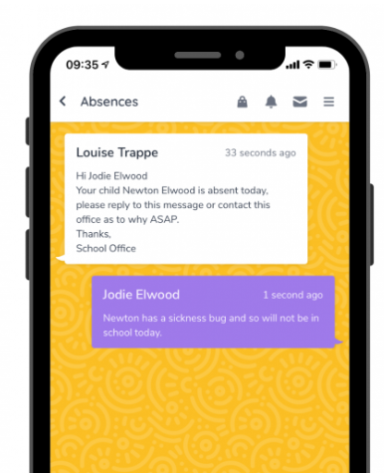
app, please contact the school office and we will
be more than happy to help.

Once logged in, you should see a screen that
looks a little like this one.

By clicking this icon on the top right of the
screen, you can then access your dashboard
which will display all the different options.

On the dashboard, you will be able to access the
following options:

- School Home: This gives links to our website for galleries, news and events.

- Parent’s Dashboard: This gives an overview of communications sent by school.

- Messages: Your class teacher may send a message for the class or for just your child.

- Survey / Forms: This is where parents can complete online surveys and forms.

- Parent’s Evenings: This will be an online booking systems for meetings in school.

- Absence: Parents can report their child’s absence (and can still phone school if you prefer).

- Awards/Reports: Your teacher might award your child for good behaviour, good work or attendance.

The absence feature is to report an absence from school only. Any communication regarding collecting your child or arrangements for pick up at the end of the day must be a phone call so to speak with an adult; this will ensure the message has been taken and received. Please do not e-mail.

This Autumn term will be very much getting this system up and running. The first whole school test event will be a questionnaire that has been set up and will go live on the 1st December.

It is our hope that with the use of this app, we can enhance our communication systems and further strengthen our relationship with our families.

Kind regards



Mr Walker
Headteacher

