8 |  | Achievements |  |  |  |  |  | Student Newspaper  Farndon Primary School
Congratulations to Anna in Year 6, who got a distinction in her drama exam grade 2.

Well done to Imogen in Foxes, won a trophy for being really good in street dance.

Congratulations to Year 6 – THE BEST IN SCHOOL- We have learnt how to draw an eye.

Well done to Ivy in Year 3, she came 3rd in her dance exam.

Congratulations to Annabel in Year 3, she passed her swimming exam.
Well done to Mollie in Year 1 who is going to donate her hair to the Princess Trust.

Nice work to Sienna in Reception, she jumped into the pool during her swimming lesson without anyone holding her hand.

Well done to a group from Year 4 on their charity cake sale. Go to page 2 for more details.

Congratulation to Ayse in Year 3, who scored her first goal for Wrexham.
^{The}FPS newspaper
1

Spring 1 2020 |  |  | Editor and Chief:  ^{Megan and Molly} |  |  |  | Issue: 150
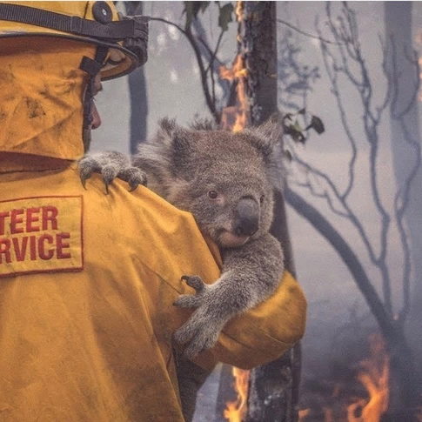
Hello, you might have heard about the Australian bush fires. It is putting lots of animals in trouble like koalas, kangaroos and many more. A staggering 1 billion animals are said to have died in these bush fires. At least 25, 000 koalas are believed to have died in the horrific wildfire in South Australia. Wildfires can also produce fire tornadoes. More than 174 fires are still burning.
Did you know that koalas are functionally extinct? (A term which means that though there are still about 80,000 koalas, they are either unlikely to reproduce another generation, prone to inbreeding due to low numbers or may no longer play a significant role in their ecosystem.)

 | ARTICLE 12, 13, 14, 15 & 31 |  |  | Saying of the month: Treat others as you wish to be treated.
School News
2
Cake Sale

Some enthusiastic people in Year 4 have raised an incredible £81! They are donated all their money to WWF to save endangered animals. They sold all of the baked goods.
Congratulations to Ava, Harriet, Edith, Freya, Jasmine, Isabella, Alexis and Ariana .

We interviewed the Year 4 group and asked why did you decide to do the cake sale?
They said they did the bake sale to support WWF (Worlds Wildlife Fund) to help them support endangered animals and the bushfire in Australia.

They said they are hoping to hold another bake sale in the summer providing drinks, cakes, brownies and biscuits.

First one to find the rose and show it to Scarlett or Gracie in Year 6 will get 15 house points.

Junior Competition
7
Your challenge is to write a poem with a Valentine theme.
Name:

Year:

Return your entry to your teacher on 24th February when we come back after half term break.

Recipe
4
How To Make Brownies
- Ingredients
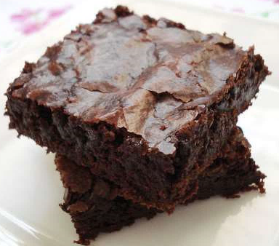
- 225g/8oz butter
- 450g/1il caster sugar
- 140g/5oz choloclate, broken into pieces.
- 5 free range medium eggs
- 110g/4oz plain flour
- 55g/2oz cocoa powder
Method
- Heat the oven up to 190c/170c fan
- Line a 20 x 30cm baking tray.
- Gently melt the butter and the sugar together in a large pan. Once melted, take off the heat and add in the chocolate. Stir until melted.
- Beat in the eggs, then stir in the rest of the ingredients.
- Pour into the prepared tin and bake for 30-40 minutes.
- Take out of the oven and cook in the tin. Cut into 5cm/2in squares when cool.
- Enjoy!
Craft
5
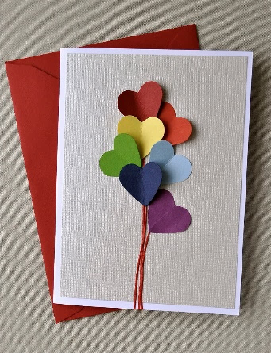
Heart Card
What you will need
Different Colour paper/card
Scissors
Glue
Pencil/pen

How to make it
Get a white piece of paper/card and fold it in half and draw a line
On the coloured card/paper draw mini hearts (one on each piece of paper/card)
Fold each of the hearts in half and put a bit of glue on the crease then arrange them on the line like abunch of flowers and press them on
Right inside of the card

Infant Competition
6
Colour in this
heart.

Name:
Year:

Return your entry to your teacher on 24th February when we come back after half term break.

Junior Safety Officers
January Focus - Belts & Car Seats & Property Marking
You have to wear a seatbelt if you are under 12 years old or smaller than 135 cm. It’s the law.
You should mark your property so that the police will know it belongs to you if it is lost or stolen. Write your postcode and your house number on the bottom or back of the item.
February Focus - School Gate Parking & Internet Safety Day
It is important that drivers follow these rules, drivers should NOT park on the school entrance markings or yellow zig zags, drivers should NOT even stop on the school entrance markings even to pick or drop someone off. School entrance markings should be kept clear of ALL stationary vehicles
Check out our noticeboard to find out how you can be SMART online
Puzzles, conundrums and things to amuse
3
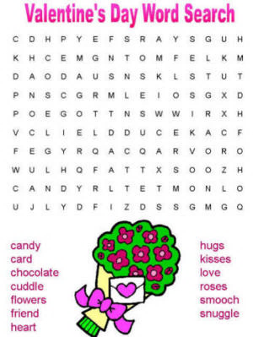
How did the phone propose to his girlfriend?
He gave her a ring
How does the moon cut his hair? Eclipse it.

