8 |  | Achievements |  |  |  |  |  | Student Newspaper  Farndon Primary School
James takes Bronze at Sailing Festival

During the summer holidays James in year 6 took part in a sailing competition at the RYA North Wales OnBoard Festival 2019 held at Bala Sailing Club. He also took part in Bart’s Bash, a charity sailing competition where he got gold.

Congragulations to those students who took part in the Storehouse Summer Reading Challenge including Isaac and Taylor in Squirrels, who received who got there medal and certificate
Congratulations to Lucy in year 6 who passed her ballet exam and got second level.
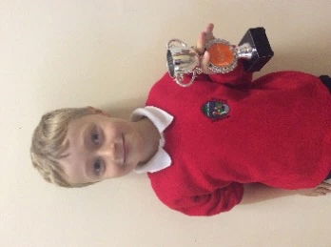
Well done to Ayse in year 3 who got into Wrexham academy and now plays for Wrexham and Max got into to Wrexham academy under 11s and Arabella got in to Chester academy under 11s.
Alex in Squirrels got a trophy for getting to the top of Blackpool Tower. He is very proud of himself. Well done!
George in year 4 is very proud of himself as he now has two Blue Peter badges!

^{The}FPS newspaper
1

Autumn 1 2019 |  |  | Editor and Chief:  ^{James B and Scarlett} |  |  |  | Issue: 13
Reducing Plastic Pollution
By Scarlett

The newspaper team are going to send a letter to McDonalds about the amount of plastic pollution that they are causing. We are concerned about how much plastic they use, we are the next generation and we don’t want to be surrounded by pollution.
I have a question who here has a parent that likes having a happy meal? I know some who do. Do they want the toy?
So we have an idea, you know how they now use those screens for you to order from, well, if after you have chosen the option ‘Happy Meal’ that it asks ‘do you want a Continued on page 2
 | ARTICLE 12, 13, 14, 15 & 31 |  |  | Saying of the month: Think positive, be positive.
News
2
Continued from page 1
toy; yes or no?’ if they press the option yes it then asks ‘do you want a book yes or no’.

We are going to be sending a letter to them about the following:
- Why do they need to use so much plastic that causes pollution?
- Can they allow customers to choose if they want the toy/gift
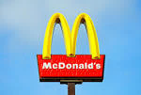
We are sending this letter to them as we are hoping to save the environment.
Say no to plastic!
Have you seen this pumpkin?
If so please show Scarlett in year 6, the first person will earn 5 house points.
Junior Competition
7
Name:
Class:
What do you call a person with no shins?
Please hand in to your teacher by the 25th of October.
The competition is to create a Halloween themed rugby ball as the rugby world cup is going on and it is nearly Halloween.
Please put your answer here:
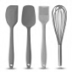
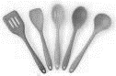
Recipe
4
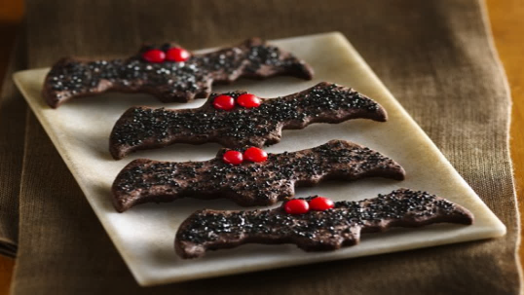
Bat Cookies
INGREDIENTS
2½ cup flour
½ cup dark chocolate powder
½ tsp ground cardamom
½ tsp ground cinnamon
½ tsp fine sea salt
½ tsp baking soda
½ tsp baking powder
TO DECORATE
Silver edible sugar pearls
Granulated sugar
Bat cutter

¾ cup dark brown sugar
1 ½ stick unsalted butter
1 large Egg
½ cup unsulphured molasses

DIRECTIONS
- In a large bowl whisk together first seven ingredients until well combined; set aside. Place sugar and butter in a large bowl; beat using the paddle attachment of an electric mixer.
- Add egg and beat until pale and fluffy, about 4 minutes.
- Add molasses, and mix to combine.
- Add flour mixture and beat until just combined, about 1 minute.
- Divide dough in half. Place each between two pieces of parchment paper, and roll to a 3/8-inch-thick disk. Refrigerate 1 hour.
- Heat oven to 325 degrees F. Dust countertop with cocoa powder.
- Transfer dough to countertop and cut cookie shaped with a 6-inch bat-shaped cutter (see note) or desired size (adjust baking time accordingly). Repeat with remaining dough.
- Place 1 inch apart on a parchment paper–lined baking sheets and bake for about 12 minutes, rotating baking sheets halfway through baking, until cookies are crisp.
- Lightly press 2 sugar pearls into each cookie for eyes.
- Let cookies cool for 5 minutes on baking sheets; transfer to wire rack to cool completely.
Craft
5
Pipe Cleaner Spiders

Its time my spooky friends,one of the best times of the year for craft. We have an amazing craft for you to do, pipe cleaner spiders 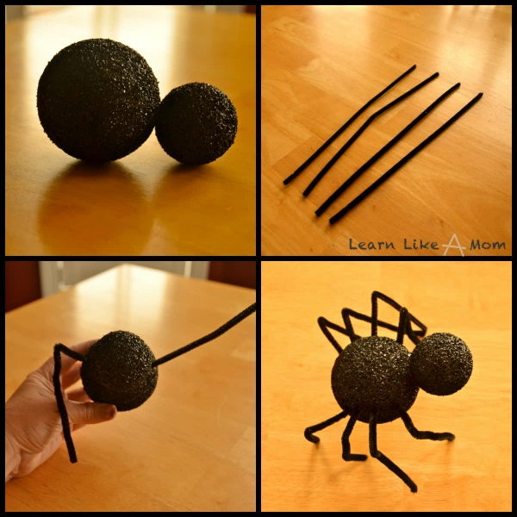
What you need:
- 2 black styrphone balls one small one big
- 4 black pipecleaners
- 8small googly eyes (Optional)
- Glue
INSTRUCTIONS
- Cut the four pipe cleaners in half.
- Push four into each side of the large styrophone ball.
- Glue the smaller ball to the larger one
- Add eyes if you wish.

Infant Competition
6
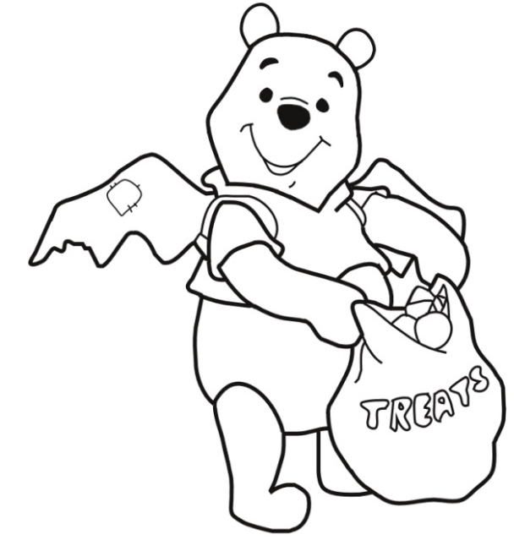
Name:
Class:

Please hand into your teacher by the 24th October.
Junior Safety Officers
Be a Breath of Fresh Air.
Don’t let your car engine idle. It is bad for the environment, it makes the air quality terrible and it wastes money. With engines idling, it creates lots noise, which makes it harder for children to hear cars that are moving.
Be Safe Be Seen
Wear bright clothing when you are out when and about so you can be seen.
Firework Safety
- Adults, be sure other people are out of range before lighting fireworks.
- Only adults should light fireworks on a smooth, flat surface away from flammable materials.
- Never try to relight fireworks that have not fully functioned.
- Keep a bucket of water in case of a malfunction or fire.

Puzzles, conundrums and things to amuse
3




