Art Curriculum Infants
Early Years Curriculum
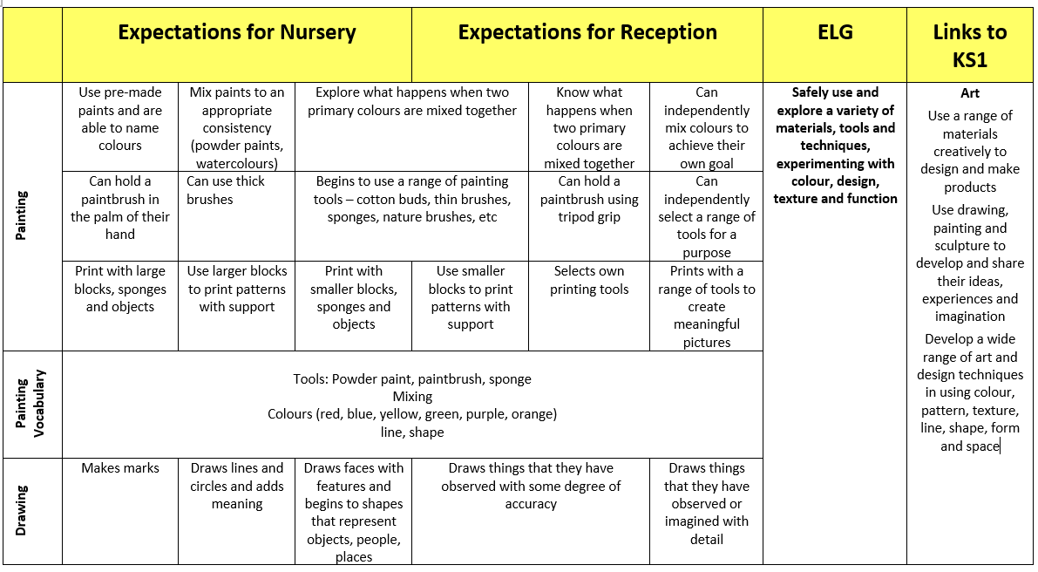
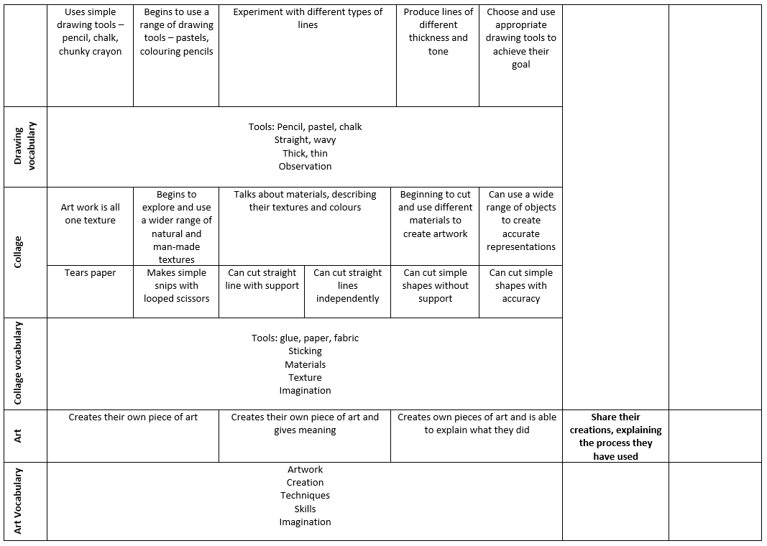
Milestone 1
Topic | Key Vocabulary | Sticky Facts | Essential Skills
Superheroes  Printing  Superhero Cityscape | Abstract  Rubbings  Relief printing  Block printing Repetition | - Abstract art is art which does not represent images of our everyday world.  - Paul Klee is an abstract artist.  - Printing makes a copy. You could paint your hand, press it down on paper and you would see a copy of your handprint.  - Relief printing is created by removing areas of a block to form a pattern, usually this is carved from the block e.g. lino or block printing.  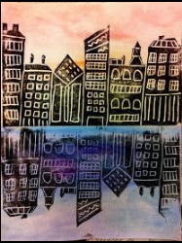 | - Create a Superhero Cityscape using printing techniques.  - Make marks in print with a variety of objects including natural and made objects.  - Make rubbings.  - Carry out different printing techniques e.g. relief printing, block printing.  - Build a repeating pattern and recognise pattern in the environment.  - Design patterns of increasing complexity and repetition.  - Print using a range of materials, objects and techniques.
Africa  Textiles  Kente Cloths Weaving | Kente cloth  Colour  Shape  Pattern  Weave  Interlace  Warp  Weft  Layer  Print | - Kente cloth is a hand-woven cloth originally made by the Ashanti people in the West African country of Ghana.  - It was originally worn by royalty, wealthy, or highly respected people. Today it is worn by all, especially for special occasions.  - It is characterised by patterns and specific colours, all of which have special meaning.  - Weaving is a textile art and craft that involves interlacing two sets of threads at right angles to form a cloth.  - The lengthwise yarns are called the warp and the crosswise yarns are called the weft.  - Weaving is usually done on a loom.  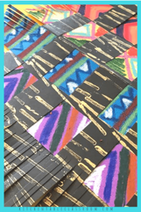  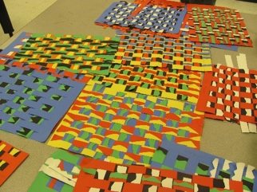  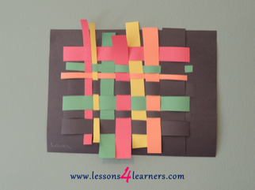 | - Create own Kente Cloth using weaving.  - Review what they and others have done and say what they think and feel about it. e.g. annotate sketchbook using language of art, craft and design.  - Use a variety of techniques e.g weaving, finger knitting, fabric crayons, sewing and binca.  - Layer different media, e.g. crayons, pastels, felt tip pens and charcoal.  - Use a wide variety of media inc. photocopied material, fabric, plastic, tissue, magazines, crepe paper etc.  - Create textured collages from a variety of media.
Land Ahoy!  Sculpture and collage  Sustainable art using natural materials  Artist:  Andy Goldsworthy  https://www.bbc.co.uk/bitesize/clips/zs87tfr  https://www.ipadartroom.com/andy-goldsworthy-inspired-lesson/ | Sculpture  Recycle  Malleable  Form  Natural Man-made  Symmetry  Colour  Tone  shape  Spiral  Wavy  Straight  Bendy  Texture | - Andy Goldsworthy is a British Artist.  - Andy Goldsworthy makes sculptures with natural materials in the UK and around the world.  - Natural resources are materials that are 'naturally' found around us. We may have to dig them out of the ground, grow them, or take them from living things.  - Andy Goldsworthy takes photographs of his work to show how they change over time.  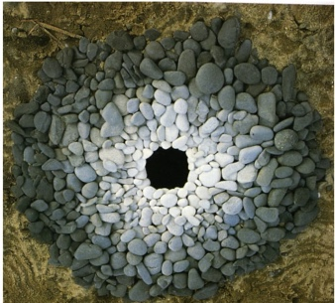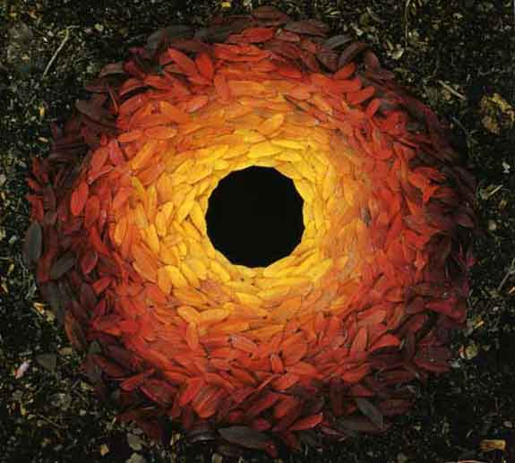 | - Create sculpture using natural materials in the style of Andy Goldsworthy.  - Manipulate malleable materials in a variety of ways.  - Explore sculpture with a range of media.  - Experiment with constructing and joining recycled, natural and man-made materials.  - Use simple 2D shapes to create a 3D form.  - Create images from imagination, experience or observation.  - Create textured collages from a variety of media.
Pole to Pole  Painting and drawing  Artist:  Nerys Levy | Shade  Tone  Smudge  Repetition  Primary colours  Construct  Landscape  Observe | - Tone can be dark, light or medium.  - Marks (dots, dashes etc.) can be used to create patterns and texture.  - Textures can be created by adding different materials to paint.  - Colours from the colour wheel create certain moods.  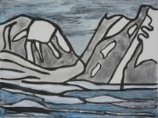  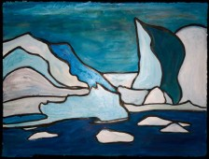 | - Paint in the style of Nerys Levy.  - Observe and draw shapes from objects.  - Use a range of marks to create pattern inc. layering different media e.g. pencil, ballpoint, pastels, crayons.  - Investigate tone by drawing light/dark lines, light/dark patterns, light/dark shapes.  - Use a variety of tools and techniques including the use of different brush sizes and types.  - Mix secondary colours and shades using different types of paint.  - Work on different scales.  - Name different types of paints and their properties (watercolour, poster, acrylic etc).  - Experiment with tools and techniques, inc. layering, mixing media, scraping through etc.
Fire! Fire!  Printing and painting  Great Fire of London  Artist:  Ann Bridges | Primary colours  Secondary colours  Abstract  Shade  Tint  Potato printing  Relief printing | - Printing makes a copy. You could paint your hand, press it down on paper and you would see a copy of your handprint.  - Potato printing is an example of relief printing.  - The three primary colours are red, blue and yellow. They are called primary colours because they cannot be made from any other colours.  - Secondary colours are made by mixing two primary colours e.g. red and yellow makes orange.  https://www.kapowprimary.com/subjects/art-design/key-stage-1/year-1/art-design-skills/craft-printing-ks1-kapow-theme-great-fire-of-london/ | - Create a ‘Great Fire of London’ scene using painting and printing skills.  - Use a variety of tools and techniques including the use of different brush sizes and types.  - Mix secondary colours and shades using different types of paint.  - Work on different scales.  - Name different types of paints and their properties (watercolour, poster, acrylic etc).  - Experiment with tools and techniques, inc. layering, mixing media, scraping through etc.  - Make marks in print with a variety of objects including natural and made objects.  - Carry out different printing techniques e.g relief printing.  - Build a repeating pattern and recognise pattern in the environment.  - Print using a range of materials, objects and techniques.
Once upon a time…  Painting, drawing and collage  Artist:  Hundertwasser | Primary colours  Secondary colours  Warm and cool colours  Shade  Tint  Tone  Layer | - Hundertwasser was a famous artist who was best known for his use of bright, dark colours and spiral shapes.  - Hundertwasser was influenced very much by nature. Many of his designs included grass, trees and plants. He often depicted trees like lollipops.  - In his artwork, he used warm and cool colours. Warm colours are red, pink, orange and yellow and cool colours are purple, blues, greens.  - The three primary colours are red, blue and yellow. They are called primary colours because they cannot be made from any other colours.  - Secondary colours are made by mixing two primary colours e.g. red and yellow makes orange.  - Pencil, pastel and paint produce different line, texture and effects.  - Pencil, pastel and paint produce different effects on contrasting backgrounds.  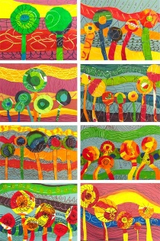 | - Create a scene from nature in the style of Hundertwasser.  - Observe and draw shapes from objects.  - Use a variety of tools, inc. pencils, rubbers, crayons, pastels, felt tips, chalk and other dry media.  - Begin to explore the use of line, shape and colour.  - Understand the basic use of sketchbook and work out ideas for drawing.  - Investigate tone by drawing light/dark lines, light/dark patterns, light/dark shapes.  - Use a variety of techniques and tools including different brush sizes and types.  - Work on different scales.  - Identify primary and secondary colours by name.  - Begin to mix shades and tones of secondary colours.

Art National Curriculum Skills
Develop Ideas | Techniques: Painting | Techniques: Drawing | Techniques: Sculpture
- Respond positively to ideas and starting points.  - Explore ideas and collect information.  - Describe differences and similarities and make links to their own work.  - Try different materials and methods to improve.  - Use key vocabulary to demonstrate knowledge and understanding in this strand: work, work of art, idea, starting point, observe, focus, design, improve. | - Name the primary and secondary colours.  - Experiment with different brushes (including brushstrokes) and other painting tools.  - Mix primary colours to make secondary colours.  - Add white and black to alter tints and shades.  - Use key vocabulary to demonstrate knowledge and understanding in this strand: primary colours, secondary colours, neutral colours, tints, shades, warm colours, cool colours, watercolour wash, sweep, dab, bold brushstroke, acrylic paint. | - Draw lines of varying thickness.  - Use dots and lines to demonstrate pattern and texture.  - Use different materials to draw, for example pastels, chalk, felt tips.  - Use key vocabulary to demonstrate knowledge and understanding in this strand: portrait, self-portrait, line drawing, detail, landscape, cityscape, building, pastels, drawings, line, bold, size, space. | - Use a variety of natural, recycled and manufactured materials for sculpting, e.g. clay, straw and card.  - Use a variety of techniques, e.g. rolling, cutting, pinching.  - Use a variety of shapes, including lines and texture.  - Use key vocabulary to demonstrate knowledge and understanding in this strand: sculpture, statue, model, work, work of art, 3D, land art, sculptor, carving, sculpture, installation, shapes, materials, pyramid, abstract, geometric.
Techniques: Collage | Inspiring Artists | Techniques: Printing | Textiles
- Use a combination of materials that have been cut, torn and glued.  - Sort and arrange materials.  - Add texture by mixing materials.  - Use key vocabulary to demonstrate knowledge and understanding in this strand: collage, squares, gaps, mosaic, features, cut, place, arrange. | - Describe the work of famous, notable artists and designers.  - Express an opinion on the work of famous, notable artists.  - Use inspiration from famous, notable artists to create their own work and compare. | - Copy an original print  - Use a variety of materials, e.g. sponges, fruit, blocks  - Demonstrate a range of techniques, e.g. rolling, pressing, stamping and rubbing.  - Use key vocabulary to demonstrate knowledge and understanding in this strand: colour, shape, printing, printmaking, woodcut, relief printing, objects. | - Show pattern by weaving.  - Use a dyeing technique to alter a textile’s colour and pattern.  - Decorate textiles with glue or stitching, to add colour and detail.  - Use key vocabulary to demonstrate knowledge and understanding in this strand: textiles, fabric, weaving, woven, placemat, loom, alternate, over, under, decoration, decorative, batik dye, dye, wax, resist, crayons, ink, apply, set.

