Geography Curriculum Milestone 3
Aspect of Geography |  | Key Vocabulary |  |  | Sticky Facts |  |  |  |  | Essential Knowledge
Walk Like an Egyptian  River Study  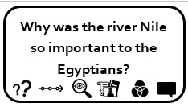  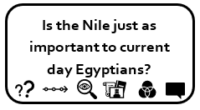 |  | Estuary  Mouth  Source  Meander  Waterfall  Erosion  Deposition  Tributary  Ox Bow lake  Delta  Stream  Vegetation belts |  |  | - Nile: The world’s longest river (4,160 miles long) and runs into the Mediterranean.  - The river flows through 4 countries (Egypt / Ethiopia / Sudan / Burundi).  - Locate Euphrates, Tigris and the Yangtze (link to the 4 settlements of Ancient Civilisations)  - Deltas are large areas of water found at the mouth of a river.  - A tributary is where one stream or river meets another.  - A meander is a winding curve or bend in a river. |  |  |  |  | - Use Google Earth to locate Egypt and follow the journey of the river Nile.  - Know the name of, and locate, a number of the world’s longest rivers  - Explain the features of the water cycle.  - Know why most cities are located by a river; explain the importance of the Nile to the Egyptians (red land / black land).  - Know and label the main features of a river.  Field work: Conduct river study in Farndon. Look at water speed; meander points; erosion; land use around river; physical and human geography; human activity.
Out Of this World  Map Study  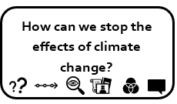 |  | Ordnance Survey  Symbol  Latitude  Longitude  Time Zone  Grid Reference  Polar circles  Equator  Climate  Average  Temperature  Rainfall |  |  | - Cartography is the study of maps and map making. Someone who makes maps is called a cartographer (John Speed famous one from Farndon).  - Map symbols are used to represent real objects. Both shapes and colours can be used for symbols on maps.  - A hemisphere is formed by dividing the earth into the Northern and Southern Hemispheres at the equator.  - The lines extending around the Earth horizontally are called lines of latitude; vertically are called longitude.  - The climate is cooler the further away from the equator.  - On the equator, the climate tends to be tropical.  - Climate means the usual condition of the temperature, humidity, rainfall, and other meteorological elements in a specific area of the Earth's surface. |  |  |  |  | - Know what most of the ordnance survey symbols are  - Know how to use six-figure grid references.  - Know the lines extending around the Earth horizontally are called lines of latitude and those that are vertical are longitude.  - Use maps and globes to locate the equator, the Tropics of Cancer and Capricorn and the Greenwich Meridian  - Use Google Earth to locate a country or place of interest.  - Understand polar-regions, times zones and tropics.  - Know about time zones and work out differences  - Know how to use graphs to record features such as temperature or rainfall across the world’s continents and climates (weather).
Endangered  South America  Rainforests  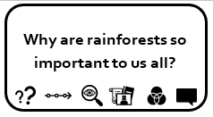 |  | Pampas  Andes  Inhabitants  Population  Atacama desert  Climate  Southern Hemisphere |  |  | - There are 12 countries in South America and almost 400 million people live there.  - Brazil is the largest country and covers almost half the continent. It is only slightly smaller than the USA.  - South America’s largest river is the Amazon, which is the second longest river in the world.  - Spanish is the most popular language in South America even though Brazilians speak Portuguese. |  |  |  |  | - Know the names of, and locate, a number of South or North American countries  - Know what is meant by biomes and what are the features of a specific biome; locate the different ones within South America and their climates.  - Know main human and physical differences between developed and third world countries  Field work: Survey of a settlement in a country in South America. Look at leisure; farming; shops; tourism; people; houses; environmental issues.
 |  | Canopy  Emergent Layer  Understory  Deforestation  Indigenous  Biomes  Temperate  Extinction  Destruction  Biodiversity |  |  | - The canopy, which may be over 30 m above the ground, is made up of the overlapping branches and leaves.  - The emergent layer is the name given to the tops of trees that poke up above the rainforest canopy.  - The understory layer is a tangle of shrubs, young trees, saplings, palms and vines.  - There are several endangered species: gorillas; jaguars; chimpanzees; poison dart frogs; orang-utans and toucans.  - The Amazon is the largest in the world and spreads across 9 countries.  - Deforestation is the clearing of trees from the land which is converted to a different use such as farming. |  |  |  |  | - Label layers of a rainforest  - Know what deforestation means  - Know what is meant by the term tropics and where generally located.
Let Me Entertain You  North America  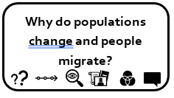  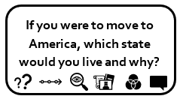 |  | States  Continent  Biomes  Equator  Weather  Climate  Tropical climate  Desert climate  Temperate  Continental  Polar  Flora  Fauna  Grand Canyon  Niagara Falls  Yosemite Valley |  |  | - The Americas are 2 separate continents and cover a huge area of the globe  - There are 23 countries in North America, with Canada being the biggest and Grenada being the smallest.  - Before the Europeans arrived, the indigenous and native Americans lived in the continent.  - Missouri river is the longest in North America and flows through seven US states.  - 2 major mountain ranges are Rocky and Appalachian.  - USA has 4 major deserts.  - There 5 main climate zones: polar; temperate; tropical; dry desert; and continental.  - The characteristics in different states vary significantly including weather, land use and flora/fauna. |  |  |  |  | - Know the names of four countries from the southern and four from the northern hemisphere  - Know why are industrial areas and ports are important (New York)  - Know main human and physical differences between developed and third world countries  - Place knowledge: identify key topographical features within the USA.  - Know the physical features of the different climates within the USA.  Field work: Client cards for what vacation / experience they might enjoy. Find where they might visit within America and why.
Traders and Raiders  Map Work  Sharing of resources / Trade  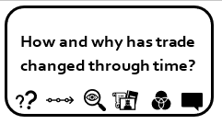 |  | Trade  Gods  Fair trade  Farmers  Import  Export  Globalisation  Supply chain  Consumer |  |  | - Trade is the action of buying and selling goods.  - Importing is bringing things into the country and exporting is taking them out.  - The UK exports gold, cars, scrap iron, medicines, aircraft parts, petroleum and gas turbines.  - The UK imports a lot of precious stones, coffee, bananas, medicines, cars, furniture and chemical products.  - Countries import because it can be cheaper, better quality or more easily accessible.  - A supply chain is the different places a product comes from and travels to on its way to a consumer.  - Fair trade is between companies in developed countries and producers in developing countries which have a fair price |  |  |  |  | - Know the names of, and locate, at least eight European countries (where Vikings / Angles / Saxons from).  - Explain what trade is and the difference between exporting and exporting.  - Use maps to locate countries we import and export goods to and from.
Child of Our Time  Map Work |  | Industry  Occupation  Europe  Allies  Axis Powers  City |  |  | - The Allied Powers were Britain, France, Russia, Belguim, Denmark, Greece, Poland, Holland, Norway and Yugoslavia (Non Europe were Australia / Canada / USA / China / New Zealand).  - The Axis Powers were Germany, Hungary, Bulgaria, Romania and Japan.  - Germany took occupation of 22 countries.  - The Blitz: the Germans targeted key industrial towns in the UK. |  |  |  |  | - Use maps to locate European countries and capitals.  - Know the names of and locate at least six cities in England  - Know the names of and locate at least eight European countries and their capital cities.  - Know why are industrial areas and ports are important; look at geographical patterns such as industrial cities bombed in the war.  - Know how the area of Farndon has changed post 1066.  - Our School badge is a strawberry. Village famous for strawberry fields. In WWII, replaced to grow crops and didn’t recover.  Field work: Use maps to compare how the land use has changed over time – since Victorian to present day.
Geography Substantive Concepts
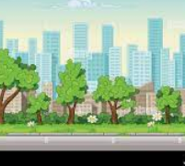 | 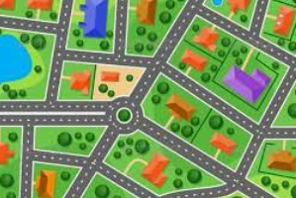 |  | 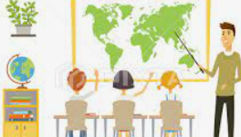 |  |  | 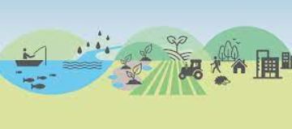 | 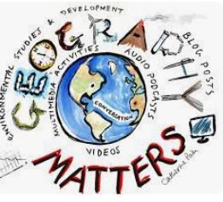 |  | 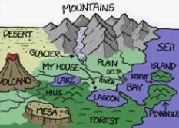 |  | 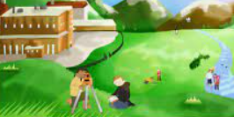 |  | 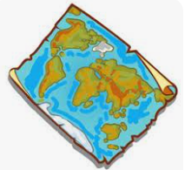
Place:  What is the place like? | Space:  How are the spaces organised |  | Size:  Personal, Local, Regional or Global |  |  | Environment: How we use the natural world | Connections: Study of people, cultures, places and processes |  | Processes: Physical and Human Geography |  | Field Work: Thinking about what places are like and why. |  | Map Skills:  Study of maps and map making
Geography Disciplinary Knowledge
Geographical Significance |  |  |  | Geographical Responsibility |  |  |  | Geographical Communication |  |  |  | Geographical Enquiry
- Identify and describe the geographical significance of latitude, longitude, Equator, Northern Hemisphere, Southern Hemisphere, the Tropics of Cancer and Capricorn, Arctic and Antarctic Circle, and time zones.  - Name and locate some of the countries and cities of the world and their identifying human and physical characteristics, including hills, mountains, rivers, key topographical features and land-use patterns; and understand how some of these aspects have changed over time.  - Name and locate the countries of North and South America and identify their main physical and human characteristics |  |  |  | - Describe geographical diversity across the world.  - Describe and explain how humans affect the earth positively and negatively through their studies on deforestation.  - Explain how climate change is having a negative impact globally and how we can improve this situation.  - Study sustainability of resources available in different countries and how geographical regions are interconnected and interdependent. |  |  |  | - Describe and understand key aspects of physical geography, including: climate zones, biomes and vegetation belts, rivers and mountains.  - Describe and understand human geography, including settlements, land use, economic activity including trade links, and the distribution of natural resources including energy, food, minerals, and water supplies.  - Use the eight points of a compass, four-figure grid references, symbols and a key (that uses standard Ordnance Survey symbols).  - Create maps of locations identifying patterns (such as: land use, climate zones, population densities, height of land through topography).  - Collect and analyse statistics and other information in order to give detailed descriptions and draw clear conclusions about locations.  - Use different types of fieldwork sampling to observe, measure and record the human and physical features in the local area.  - Analyse and give views on the effectiveness of different geographical representations of a location (such as aerial images compared with maps and topological maps). |  |  |  | - Ask geographical enquiry questions such as: Should we be allowed to conduct deforestation in the Amazon rainforest? What are the possible affects of global warming? Why is the Nile so vital to the people of Egypt?  - Understand some of the reasons for geographical similarities and differences between countries.  - Describe how locations around the world are changing and explain some of the reasons for change.  - through study on trade.  - Identify and describe how the physical features can effect the human activity within a location.

