Geography Curriculum Milestone 1
EARLY YEARS CURRICULUM
Expectations for Pre-School |  |  |  |  |  | Expectations for Reception |  |  |  |  | ELG |  | Key Vocab
Knows that we live in Farndon | Knows that our country is England |  | Knows that there are different countries in the world |  |  | Can ask questions about the world and enjoys looking at maps | Recognise some environments that are different to the one in which they live |  | Recognise some similarities and differences between life in this country and life in other countries |  | Describe their immediate environment using knowledge from observation, discussion stories, non-fiction texts and maps  Explain some similarities and differences between life in this country and life in other countries, drawing on knowledge from stories, non-fiction texts and (when appropriate) maps. |  | Plan,  Birds eye view  Arial view,  Map  country, ocean, environment, mountain
 |  |  |  |  |  | Field Work Skills  Can recognise classroom objects/shapes on a birds eye view/aerial plan of their table.  Provide lots of experiences of viewing objects from above and talk about how different they look and why. | Field Work Skills  Can compose and draw their own aerial view plan containing 5 objects on their table |  | Field Work Skills  Can represent and draw a larger more complex plan of more than 5 objects on the carpet.  Introduce simple arial plans of the classroom then school. Be able to follow a route around the class then school using the plans. |  |  |  | Links to KS1
Name and locate the world’s 7 continents and 5 oceans
Name, locate and identify the 4 countries and capital cities of the United Kingdom
Understand geographical similarities and differences through studying the human and physical geography
Area |  | Key Vocabulary |  |  | Sticky Facts |  |  |  |  | Essential Knowledge
Comparative study non European country  Out of Africa  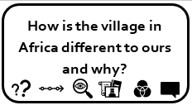  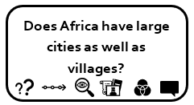 |  | European  African  Wildlife  Climate  Drought  Mud Huts  Savannah  Lake Turkana |  |  | - Kenya is situated in Eastern Africa and its capital of Kenya is Nairobi.  - There are two main languages spoken in Kenya: English and Swahili. However there are many other languages.  - Kenya has a coast line on the Indian Ocean.  - Large animals such as lions, buffalo, leopards, elephants and rhinoceros are present in Kenya.  - Kenya is still a developing country and more than half the population live in poverty. |  |  |  |  | - Identify certain physical features within African continent: dry savannahs; mountains; Great Rift Valley.  - Know the main differences between our village and that of a small place in Africa.  Field work: Walk around the village to gather physical and human geography data. Compare and contract to a village in Kenya.
Human and Physical Geography  Pole to Pole  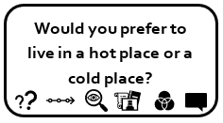  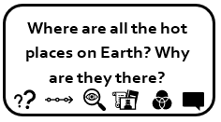 |  | North Pole  South Pole  Equator  Arctic  Antarctic  Desert  Hemisphere  Humid  Oceans  Continents |  |  | - Identify animals that live in the polar regions: penguins; polar bears; arctic fox; seals; reindeer; walrus.  - Not all deserts are hot. Two of the world’s biggest deserts are in the North and South Poles.  - The largest hot desert in the world is the Sahara and the largest cold desert is Antarctica.  - Name the 5 oceans: Arctic; Pacific; Indian; Atlantic; and Southern.  - Name the seven continents: Europe; Asia; North America; South America; Africa; Oceania; and Antarctica. |  |  |  |  | - Know where the equator, North Pole and South Pole are on a globe.  - Know features of cold and hot places in the world – North and South Poles and around the equator.  - Know and recognise main weather symbols  - Know the names of and locate the five oceans of the world  - Know the names of and locate the seven continents of the world.  - Use world maps, atlases and globes to identify the United Kingdom continents and oceans studied at this key stage
Human and Physical Geography  Land Ahoy  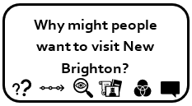  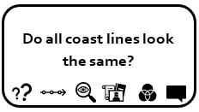 |  | Cliff  Rock pool  Resort  Tide  Beach  Lighthouse  Ocean  Island  Coast |  |  | - Coasts have many different features, such as caves, cliffs, mudflats and beaches.  - Visits to the seaside were famous for their punch and judy shows, sandcastles, piers, and fish and chips in newspaper.  - The UK coastline is one of the longest in the world.  - Beaches may be sandy, rocky, muddy, or covered in shingle. |  |  |  |  | - Know which is the hottest and coldest season in the UK  - Identify the following physical features of the British coastline: cliff; beach; sea; ocean; season; and weather.  - Identify human features at the seaside: port; harbour; shops; theatre houses.  - Identify different types of coast.  Field work: Visit coastline (New Brighton). Look for aspects of a coastal settlement including both human and physical geography.
Geographical skills and field work  Once Upon a Time…  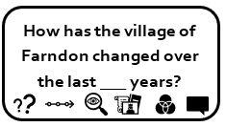  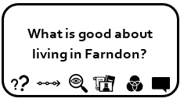 |  | Street  Office  Farm  House  Church  Address  Map Symbol  Postcode  Rural  Town / Village  Atlas |  |  | - A village is usually associated with the countryside and is smaller than a town.  - Every street in our country has a name and a post code. The name is usually on a wall or a sign at the beginning of the street.  - Your address has the name of the street you live in, the number or name of your house; the village, town or city you live in and a post code.  - The River Dee runs through the village. |  |  |  |  | - Know their address, including postcode  - Use simple fieldwork and observational skills to study the geography of their school and surrounding area.  - Know which is N, E, S and W on a compass. Relate to map work of the local area and following directions.  - Know and use the terminologies: left and right; below and next to; relate to map work on local area (create basic maps of area from direct experience).  - Use aerial photographs and plan perspectives to recognise landmarks and basic human and physical features in Farndon.  - Devise simple maps and use and construct basic symbols in a key.  - Identify key Physical (river ) and Human (village / house / farm / office / shop) geography.  Field work: Walk around village taking photographs. Use to create simple overhead maps of the area around school  Conduct simple questionnaire about our village and how it could be improved.
Locational Knowledge  Fire Fire  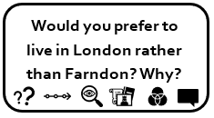 |  | Capital  City  British Isles  United Kingdom  Sea  Country |  |  | - London is our capital city and has a population of more than 8 million.  - London is the capital of England; Cardiff the capital of Wales, Edinburgh the capital of Scotland and Belfast the capital of Northern Ireland.  - One of the oldest parliaments in the world is situated in London and is called the Houses of Parliament.  - UK made up of England, Northern Ireland, Scotland and Wales.  - UK surround by Irish Sea, North Sea and Atlantic Sea. |  |  |  |  | - Know the main differences between city, town and village  - Explain some of the advantages and disadvantages of living in a city or village.  - Know the name of and locate the four capital cities of England, Wales, Scotland and Northern Ireland  - Know the names of the four countries that make up the UK and name the three main seas that surround the UK  - Use world maps, atlases and globes to identify the United Kingdom and its countries.  Field work: Look at our village, its physical geography, human geography and amenities. Draw comparison between village / town / city.
Geography Substantive Concepts
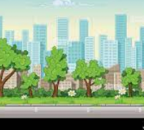 | 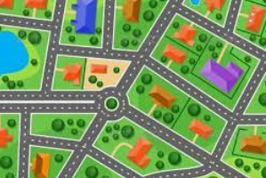 |  |  |  |  | 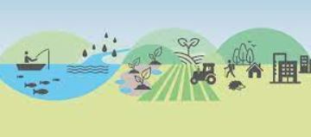 |  |  | 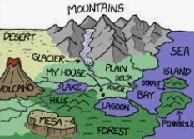 |  | 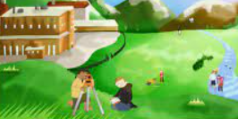 |  | 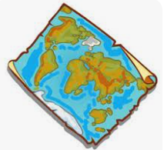
Place:  What is the place like? | Space:  How are the spaces organised |  | Size:  Personal, Local, Regional or Global |  |  | Environment: How we use the natural world | Connections: Study of people, cultures, places and processes |  | Processes: Physical and Human Geography |  | Field Work: Thinking about what places are like and why. |  | Map Skills:  Study of maps and map making
Geography Disciplinary Knowledge
Geographical Significance |  |  |  | Geographical Responsibility |  |  |  | Geographical Communication |  |  |  | Geographical Enquiry
- Identify the key features of a location in order to say whether it is a city, town, village, coastal or rural area.  - Name, locate and identify characteristics of the four countries and capital cities of the United Kingdom and its surrounding seas.  - Name and locate the world’s continents and oceans. |  |  |  | - Study how we affect the Earth both positively and negatively and identify land use around the school.  - Ask how we affect the coast lines both positively and negatively.  - Ask how the change in climate is affecting the north and south pole. |  |  |  | - Use basic geographical vocab to refer to key physical features, including: beach, coast, forest, hill, mountain, ocean, river, soil, valley, vegetation and weather.  - Use basic geographical vocab to refer to key human features, including: city, town, village, factory, farm, house, office and shop.  - Use world maps, atlases and globes to identify the UK and its countries, as well as the countries, continents and oceans studied.  - Use simple fieldwork and observational skills to study the geography of the school and the key human and physical features of its surrounding environment.  - Use aerial images and plan perspectives to recognise landmarks and basic physical features.  - Devise a simple map with basic symbols in a key. Use simple grid references and 4 compass points. |  |  |  | - Ask and answer geographical questions like what is this place like? Who or what might live in this place?  - Understand geographical similarities and differences through studying the human and physical geography of an area in UK and Africa.  - Identify seasonal and daily weather patterns and the location of hot and cold areas of the world in relation to the Equator. Understand the cause and effect of this weather.  - Study continuity and change through how and why physical and human features have changed over time.

