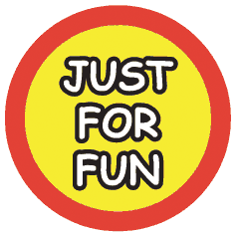
Junior

Safety

Officers

Easter Egg Hunt 2023

Match the letter to the picture to spell out a safety message.

Outside School – Notice Board | Fancy a drink ask Lewis | See the Light near the Hare | Go to St Chads.

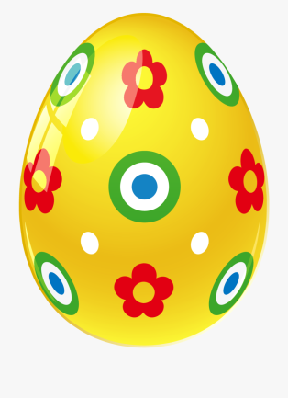
Play sports and be Social at the Club Ground | Free Parking by the Doctors | Head East out the village to get the last bus. | Playground in a quarry.

Read the clues and find the letters.

They are all hidden around Farndon.

