**Phase 2**

**Maths Examples**

**1 Count to 100**

|  |  |  |  |  |  |  |  |  |  |
| --- | --- | --- | --- | --- | --- | --- | --- | --- | --- |
| 1 | 2 | 3 | 4 | 5 | 6 | 7 | 8 | 9 | 10 |
| 11 | 12 | 13 | 14 | 15 | 16 | 17 | 18 | 19 | 20 |
| 21 | 22 | 23 | 24 | 25 | 26 | 27 | 28 | 29 | 30 |
| 31 | 32 | 33 | 34 | 35 | 36 | 37 | 38 | 39 | 40 |
| 41 | 42 | 43 | 44 | 45 | 46 | 47 | 48 | 49 | 50 |
| 51 | 52 | 53 | 54 | 55 | 56 | 57 | 58 | 59 | 60 |
| 61 | 62 | 63 | 64 | 65 | 66 | 67 | 68 | 69 | 70 |
| 71 | 72 | 73 | 74 | 75 | 76 | 77 | 78 | 79 | 80 |
| 81 | 82 | 83 | 84 | 85 | 86 | 87 | 88 | 89 | 90 |
| 91 | 92 | 93 | 94 | 95 | 96 | 97 | 98 | 99 | 100 |

**2 Count in twos**

|  |  |  |  |  |  |  |  |  |  |
| --- | --- | --- | --- | --- | --- | --- | --- | --- | --- |
| 1 | 2 | 3 | 4 | 5 | 6 | 7 | 8 | 9 | 10 |
| 11 | 12 | 13 | 14 | 15 | 16 | 17 | 18 | 19 | 20 |
| 21 | 22 | 23 | 24 | 25 | 26 | 27 | 28 | 29 | 30 |
| 31 | 32 | 33 | 34 | 35 | 36 | 37 | 38 | 39 | 40 |
| 41 | 42 | 43 | 44 | 45 | 46 | 47 | 48 | 49 | 50 |

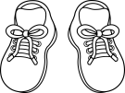

**They are all EVEN**

**They all end in 0 or 2 or 4 or 6 or 8**

**2 Count in fives**

|  |  |  |  |  |  |  |  |  |  |
| --- | --- | --- | --- | --- | --- | --- | --- | --- | --- |
| 1 | 2 | 3 | 4 | 5 | 6 | 7 | 8 | 9 | 10 |
| 11 | 12 | 13 | 14 | 15 | 16 | 17 | 18 | 19 | 20 |
| 21 | 22 | 23 | 24 | 25 | 26 | 27 | 28 | 29 | 30 |
| 31 | 32 | 33 | 34 | 35 | 36 | 37 | 38 | 39 | 40 |
| 41 | 42 | 43 | 44 | 45 | 46 | 47 | 48 | 49 | 50 |

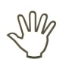

They all end in 0 or 5

**2 Count in 10s**

|  |  |  |  |  |  |  |  |  |  |
| --- | --- | --- | --- | --- | --- | --- | --- | --- | --- |
| 1 | 2 | 3 | 4 | 5 | 6 | 7 | 8 | 9 | 10 |
| 11 | 12 | 13 | 14 | 15 | 16 | 17 | 18 | 19 | 20 |
| 21 | 22 | 23 | 24 | 25 | 26 | 27 | 28 | 29 | 30 |
| 31 | 32 | 33 | 34 | 35 | 36 | 37 | 38 | 39 | 40 |
| 41 | 42 | 43 | 44 | 45 | 46 | 47 | 48 | 49 | 50 |

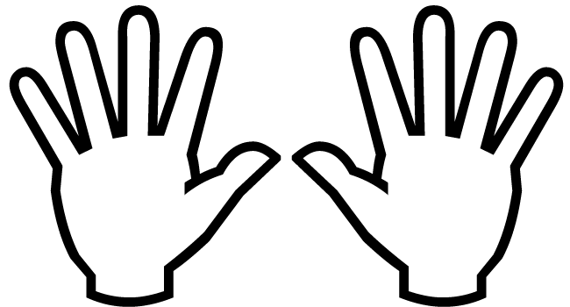

They all end in 0

**3 One more or less**

|  |  |  |
| --- | --- | --- |
| 4 | 5 | 6 |

1 less than 1 more than

|  |  |  |
| --- | --- | --- |
| 27 | 28 | 29 |

**4 Numbers as objects**

Max

has

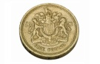

Ann

has

**Max has MORE than Ann**

**Max has the MOST**

**Ann has LESS than Max**

**Ann has the LEAST**

**5 Numbers in figures and words**

1 one

2 two

3 three

4 four

5 five

6 six

7 seven

8 eight

9 nine

10 ten

11 eleven

12 twelve

13 thirteen

14 fourteen

15 fifteen

16 sixteen

17 seventeen

18 eighteen

19 nineteen

20 twenty

**6 Mathematical statements involving (+)**

**(-) and (=)**

**We read:** 3 added to 4 makes 7

**We write:** 3 + 4 = 7

**We read:** 7 subtract 3 makes 4

**We write:** 7 - 3 = 4

**7 Number bonds**

**1 + 9 = 10 OR 9 + 1 = 10**

**10 – 1 = 9 OR 10 – 9 = 1**

**2 + 8 = 10 OR 8 + 2 = 10**

**10 – 2 = 8 OR 10 – 8 = 2**

**3 + 7 = 10 OR 7 + 3 = 10**

**10 – 3 = 7 OR 10 – 7 = 3**

**4 + 6 = 10 OR 6 + 4 = 10**

**10 – 4 = 6 OR 10 – 6 = 4**

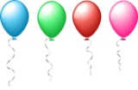

**5 + 5 = 10**

**10 – 5 = 5**

**8 Addition and subtraction**

I need +2 to make 10

**Addition**

**Example: 8 + 6**

**= 8 + 2 4**

**= 10 + 4**

**= 14**

**+**

I need -3 to make 10

**Subtraction**

**Example: 13 - 5**

**13 - 3 2**

**= 10 - 2**

**= 8**

**9 Addition & subtraction problems**

3 balloons and 4 balloons make 7 balloons

**+ =**

We can write: 3 + 4 = 7

****7 balloons and 3 balloons burst leaves 4 balloons

-

=



**We can write:** 7 - 3 = 4

**NOTICE 7 - 3 = 4**

**3 + 4**

**10 Multiplication and division**

* A gardener sows some bean seeds

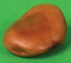****

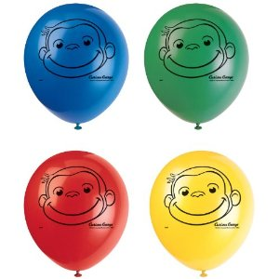



* How many seeds did he plant?

Answer: 3 x 5 = 15

or 5 x 3 = 15

* The gardener planted 15 seeds in 3 rows. How many seeds in each row?

Answer: 15 ÷ 3 = 5

**11 Recognise and name a half**

**We write: **

Split into two equal parts

** YES  NO!!!!**

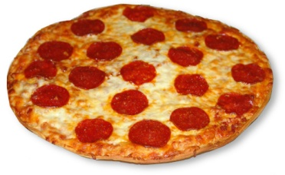

Half of a rectangle



Half of the balloons

**12 Recognise and name a quarter**

**We write: **

quarter of a rectangle

quarter of the balloons

**13 Measures**

* mass/weight

lighter

heavier

* capacity/volume

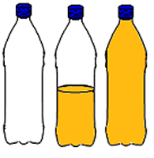

full

empty

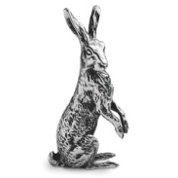

less more

* time

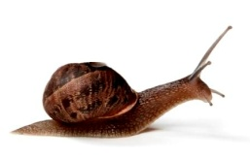

faster

slower

* **l**ength

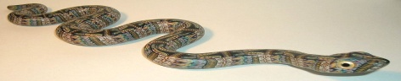

**http://www.earthdesign.co.uk/images/small%20snake.jpg**

long

short

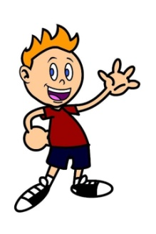**14 Measuring**

* mass/weight

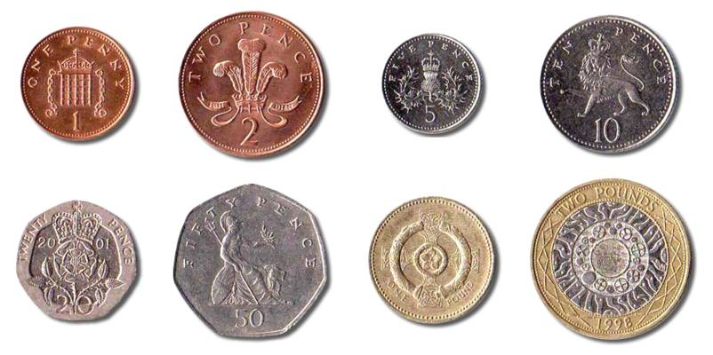weight of an apple – grams

weight of a boy - kilograms



* 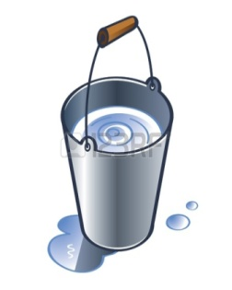capacity/volume

medicine spoon - millilitres

bucket of water – litres

* 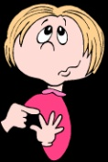time

count to 20 – seconds



eat your dinner – minutes

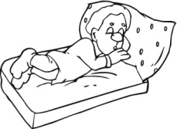

sleep - hours

* 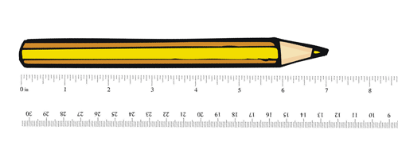Length

A pencil – centimetres

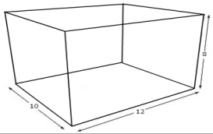

The school hall – metres

Road distance– kilometres

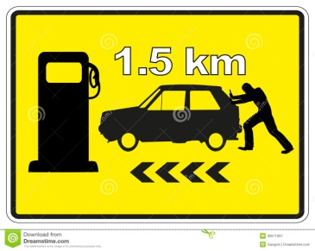

**15 Value of coins**

**1p 2p 5p 10p**

**20p 50p £1 £2**

**15 Value of notes**

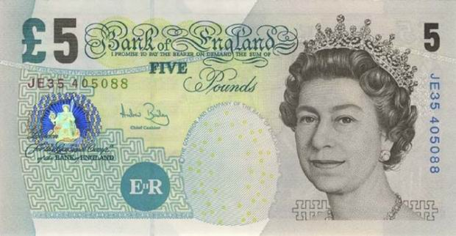

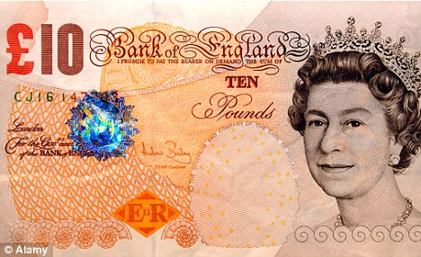

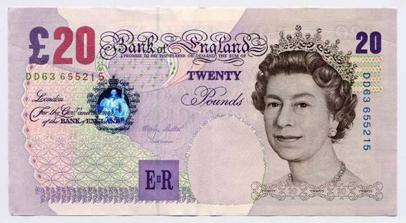

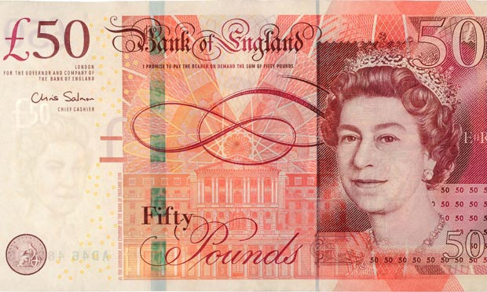

|  |  |
| --- | --- |
| 1. Watched some TV http://www.larrypatten.com/wp-content/uploads/2013/03/cartoon-boy-watching-tv.gif | 2. Came home from schoolhttps://encrypted-tbn3.gstatic.com/images?q=tbn:ANd9GcR56Ktf9EHhLY-h6p4S_f07L7Z8jLk3RCFNWpcgGvpYdu94do2s |
| 3. Brushed my teethhttp://www.colourbox.com/preview/5864921-179775-a-young-boy-brushing-his-teeth.jpg | 4. Went to bed http://www.njfamily.com/Real-Moms-of-NJ/March-2012/Ready-to-Transition-from-Crib-to-Bed/Boy-Bed-500V.jpg |
| 5. Had my teahttp://www.novita.org.au/library/boy-eating_sandwitch.gif | 6. Did my homeworkhttp://www.clipartguide.com/_named_clipart_images/0511-0908-2515-5723_Kid_Doing_His_Homework_clipart_image.jpg |

**16 Sequence events**

**17 Dates**

**20p 50p £1 £2**

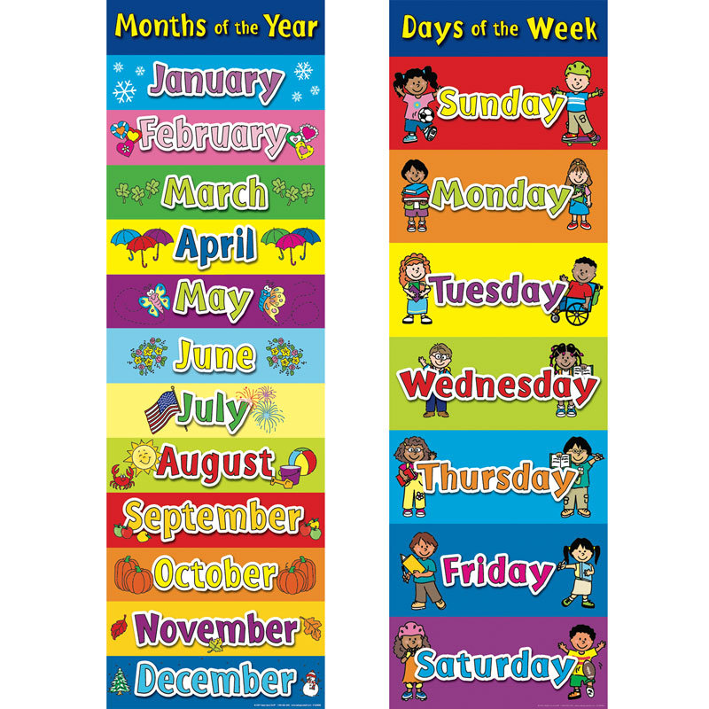

**To write the date**

Today is Thursday 3rd April 2015

**18 Tell the time**

The long pointer is called the MINUTE hand.

The short pointer is called the HOUR hand

When the **long pointer** is on 12, we say **o’clock**

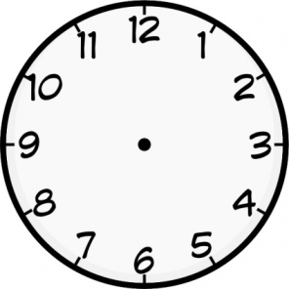

8 o’clock 3 o’clock

When the **long pointer** is on 6, we say **‘half past’**



Half past 2 Half past 9

**19 Recognise 2D shapes**

* Rectangle
* Square
* Triangle
* Circle

**19 Recognise 3D shapes**

* Cuboid
* Cube
* Pyramid

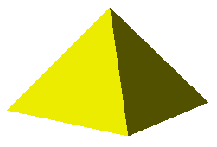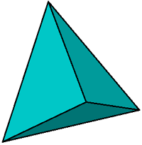

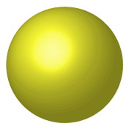

* Sphere

**20 Position, direction and movement**

* **Position**

|  |  |  |
| --- | --- | --- |
|  |  |  |
|  |  |  |
|  |  |  |

What shape is **above** the cuboid?

Answer: circle

What shape is **below/under** the blue triangle?

Answer: yellow triangle

What shape is **right** of the green pentagon?

Answer: sphere

What shape is l**eft** of the circle?

Answer: square

* **Direction**

Forward Backward Turn right Turn left

* **Movement**

ANTICLOCKWISE CLOCKWISE

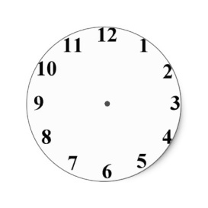

Clockwise (1 right angle)

or ¼ turn



Clockwise(2 right angles) or ½ turn



Clockwise(3 right angles) or ¾ turn